Network architecture and protocol Exam sheet:
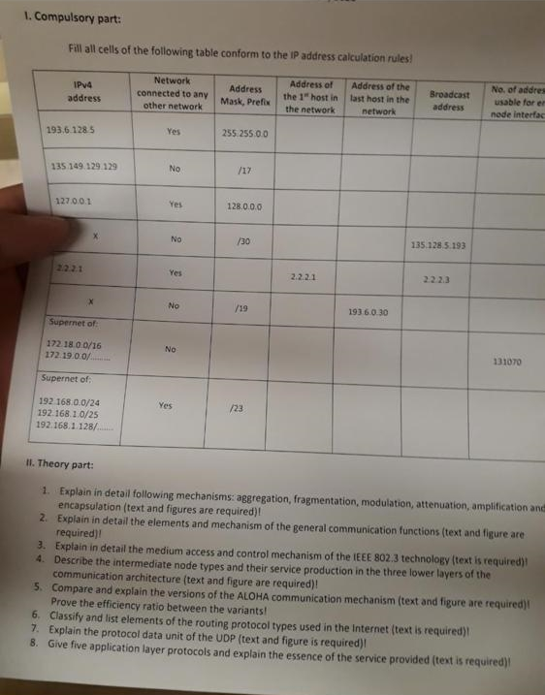

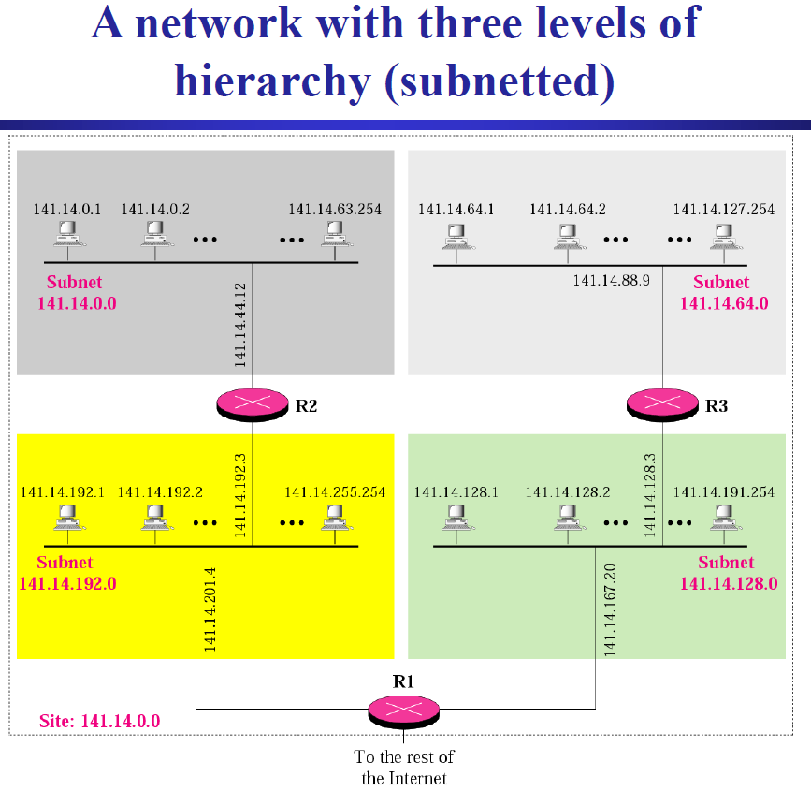
Subnet 1
Subnet 4
Subnet 3
Subnet 2
No. of usable IP addresses
= (All of the subnetwork address range) – (Network addr) – (Broadcast addr) – (No. of routers)
= All – 1 – 1 – depends on which interface
For example, in above figure, only one IP addr is occupied for each subnet 1 and 2 by a router (R2 for subnet1, R3 for subnet2). Therefore No. of routers is 1 for each interface. Formula will be All – 2 – 1 for subnet 1 and 2.
Whereas, two IP addr are used for each subnet 3 and 4 (R1 and R2 for subnet3, R1 and R3 for subnet4). Hence, No. of routers is 2 for each interface. Formula will be All – 2 – 2 for subnet 3 and 4.

Answers:
- Compulsory part

- Theory part
- Explain in detail following mechanisms: aggregation, fragmentation, modulation, attenuation, amplification, and encapsulation (text and figures are required).
Aggregation: It is synonym to supernet, the procedure to combine the small networks into larger space.

Fragmentation: It is the process by the network layer to fragment IP datagram into smaller unit in the case IP datagram is bigger than the MTU. Fragmentation can be done at the sender or at intermediate routers. Fragments are reassembled at receiver (defragmentation).
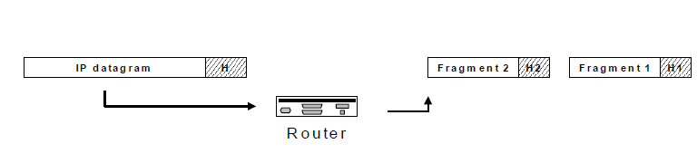

Modulation: It is the process of combining message signal (=binary data) and carrier signal to send an analogue message signal (=channel signal) on channel. The MODEM device executes modulation task when it transmits signal, and demodulation task when it receives signal.
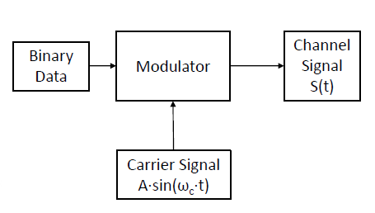

Attenuation: It is the ratio of transmitted and received signal power, in other words, original signal and corrupted signal power.
Attenuation = 10 * log₁₀(received signal power / transmitted signal power)

Amplification: It is the process by amplifier increasing the amplitude of the signal, namely, increasing the voltage, current, or power of a signal. An amplifier might be similar to a repeater, but repeater is used to regenerate the signal. Hence, amplification may produce noise.
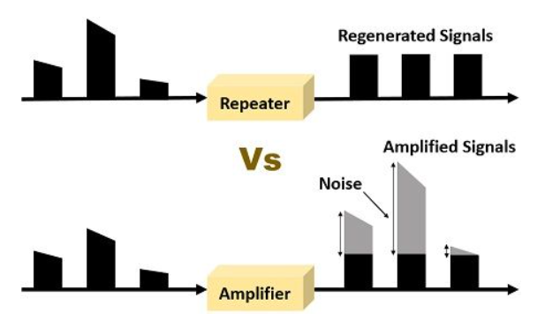
Encapsulation: It is the process wrapping chunks of data into different format to transmit to an adjacent layer or over communication medium. Roughly speaking, the process adding header info (and possibly tail info). Header contains necessary information for receiver to reorder fragmented PDUs. Tail contains information to check error (because of fragmentation process, an error might occur, i.g. some fragment was dropped during transmission).

- Explain in detail the elements and mechanism of the general communication function (text and figure required).
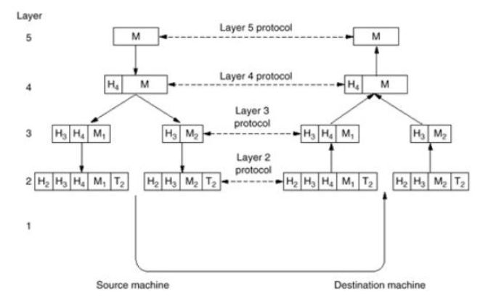
Encapsulation
Encapsulation
Encapsulation
And
Fragmentation
Source machine:
Layer 5 (Session layer):
A message is established.
L5/4 interface:
Physically the message from L5 entity is transmitted to the L4 entity.
L4 (Transport layer):
The header information is added. The process adding header information is called encapsulation. Encapsulation is necessary for receiver to reorder fragmented PDUs.
* PDU: unit of data in OSI model, containing header information.
L4/3 interface:
In this case, fragmentation occur because of message size limit of L3, so the message needs to be splited.
Fragmentation occur in N/N+1 interface if layer N does not have enough message size limit.
Transfer fragmented PDUs separately.
L3 (Network layer):
Encapsulation occurs again and additional header info is added to each fragmented PDU.
L3/2 interface:
Transfer PDUs separately.
L2 (Data link layer):
Encapsulation occurs again.
Tail information is added, this is used to check if there is error in PDU because of the fragmentation process.
Between source machine and destination machine:
Every PDU is transmitted.
Destination machine:
From the bottom layer:
The inverse processes occur respectively, such that decapsulation, defragmentation, removal of header/tail information.
Receive message finally at session layer.

- Explain in detail the medium access and control mechanism of the IEEE 802.3 technology (text is required).
Medium access control (MAC) sublayer is the layer that controls the hardware responsible for interaction with the transmission medium. The MAC sublayer and the logical link control (LLC) sublayer together make up the data link layer. Within the data link layer, the LLC provides flow control and multiplexing for the logical link, while the MAC provides flow control and multiplexing for the transmission medium.

- Describe the intermediate node types and their service production in the three lower layers of the communication architecture (text and figure are required).
Network layer: Router
Data link layer: Bridge, switch
Physical layer: repeater, HUB

Router: This device can divide a network, broadcast domain.
It forwards packets.
Each interface segment has unique physical and unique logical address.
Router makes a decision which path is used to send packets.
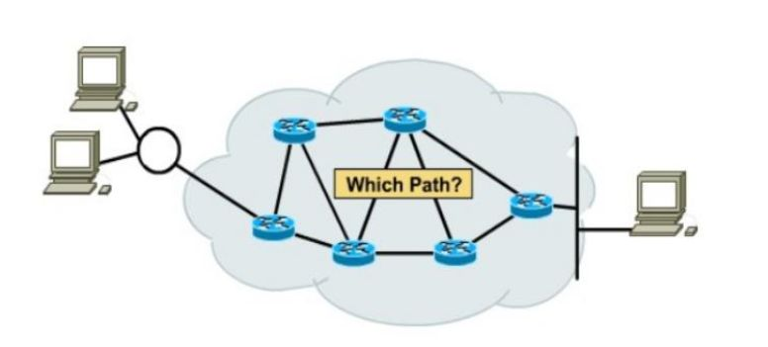
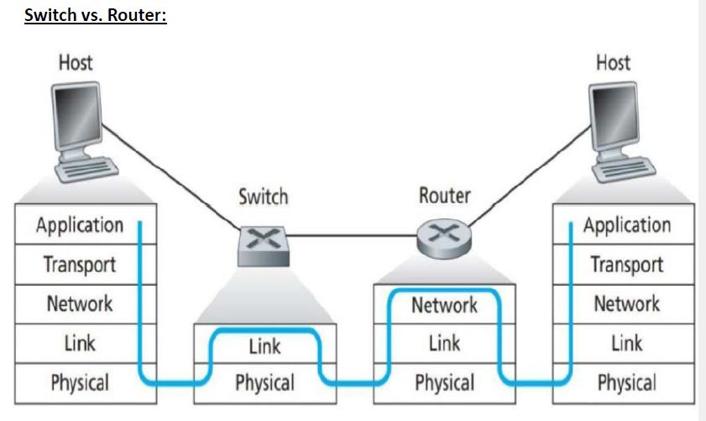
Bridge: This device separates a network and collision domain into segments. Thus, the number of collisions on the network is reduced. Each collision domain has its own separate bandwidth, so a bridge also improves the network performance.
Bridge is not widely used anymore in modern LANs. Switch is commonly used instead.
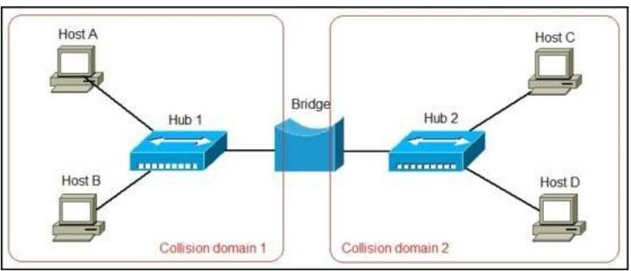
Switch: This device is mainly used for the transfer of the data packets.
In below picture, C and D computers can communicate during communication between A and B (collision does not happen), unlike with hub.
Switch recognizes destination by header of PDU containing source and destination ID.
If transmission has not occurred before, switch cannot recognize destination nodes. Thus, broadcast signal transmission is needed for switch at the first communication so that sender’s port number can be memorized by switch. Then, that port number can be used as a destination port for the next communication.
Switch also has the same function of hub (broadcast signal transmission).
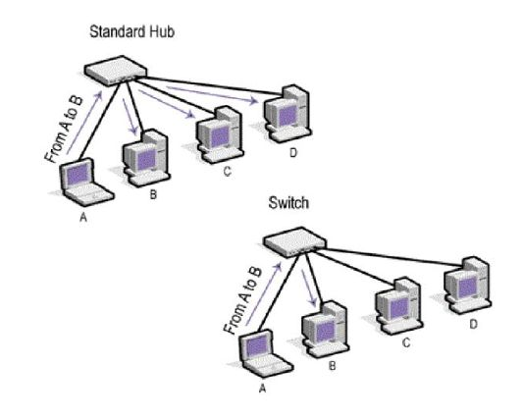


Repeater: The energy of signal may decrease because of distortion of transmission. This device regenerates signal from that corrupted signal. This can receive one signal and regenerate multiple signals.
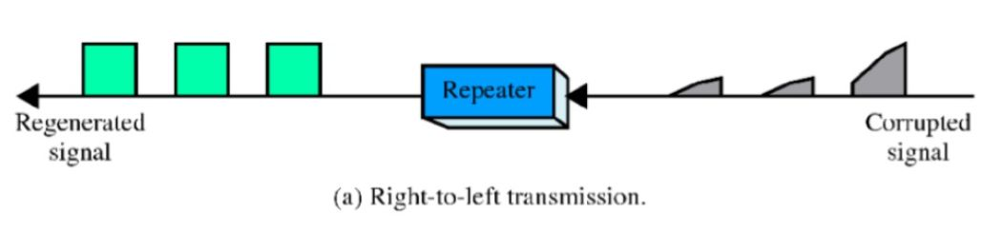
Hub: This device is used to connect segments of a LAN. It contains multiple input/output ports. When signal is at any input port, this signal will be made at all output ports except the one it is coming from (broadcast communication).


- Compare and explain the versions of ALOHA communication mechanism (text and figure are required). Prove the efficiency ratio between the variants.
ALOHA can be categorized into two, (pure) ALOHA and slotted ALOHA.

Pure ALOHA:
Pure ALOHA allows stations to transmit whenever they have data to be sent.
When a station sends data, it waits for an acknowledgement.
If the acknowledgement doesn’t come within the allotted time, the station waits for a random amount of time called back-off time (Tb) and re-sends the data.
Since different stations wait for different amount of time, the probability of further collision decreases.
Main advantage is pure ALOHA is easy to implement.
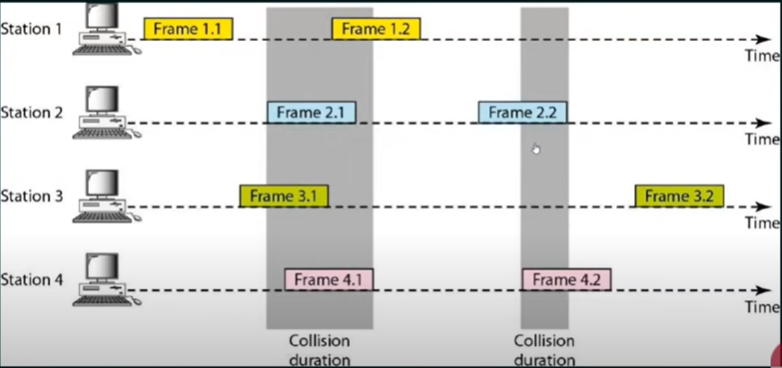

Slotted ALOHA:
Slotted ALOHA was developed to improve the efficiency of pure ALOHA as the chances for collision in pure ALOHA are high.
The time of the shared channel is divided into discrete time intervals called slots.
Sending of data is allowed only at the beginning of these slots.
If a station misses out the allowed time, it must wait for the next slot. This reduces the probability of collision.
Main advantage is slotted ALOHA reduces the number of collisions to half, and doubles the efficiency of pure ALOHA.
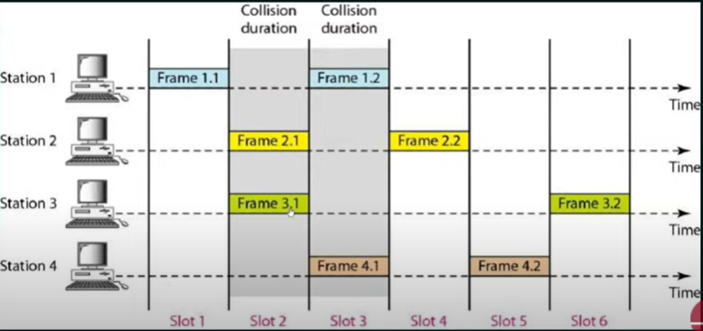

- Classify and list elements of the routing protocol types used in the internet (text is required).
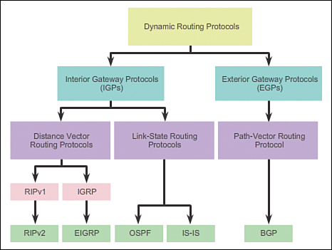
RIP = Routing information protocol
IGRP = Interior gateway routing protocol
EIGRP = Enhanced interior gateway routing protocol
OSPF = Open shortest path first
IS-IS = Immediate system-to-immediate system
BGP = Border gateway protocol
Most routers use dynamic routing.
IGPs are used for routing within an autonomous system (AS).
EGPs are used for routing between AS.
Distance vector routing protocols are advertised by providing two characteristics:
Distance identifies how far it is to the destination network, based on a metric such as the hop count, cost, bandwidth, delay, and more.
Vector specifies the direction of the next-hop router or exit interface to reach the destination.
Link-State routing protocols can create a complete view or topology of the network by gathering information from all of the other routers.
Path-Vector routing protocol maintains the path information that gets updated dynamically.

- Explain the protocol data unit of the UDP (text is required).
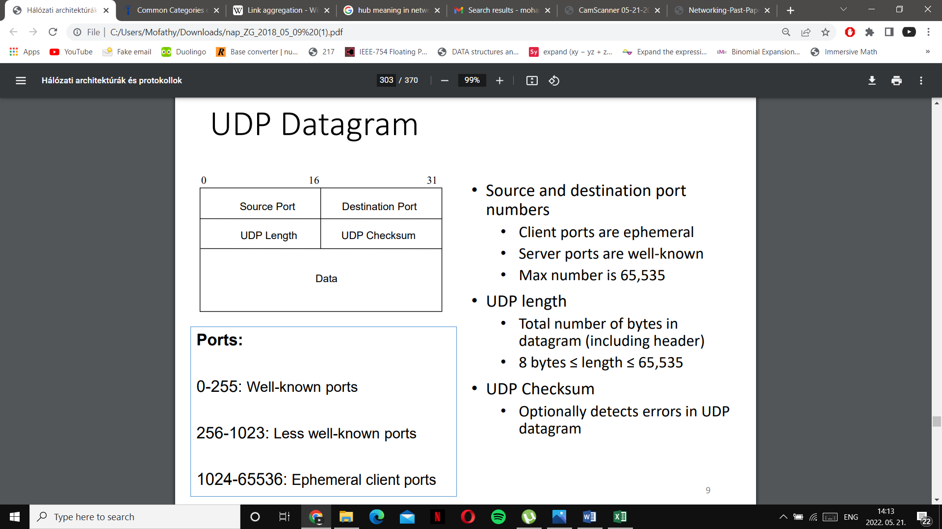

Explanation for header part:
Source port identifies the port sending application.
Destination port identifies the port receiving application.
Length field identifies the combined length of UDP header and encapsulated data.
Length = Length of UDP Header + Length of encapsulated data
Checksum detects error, but it’s not mandatory in UDP.

- Give five application layer protocols and explain the essence of the service provided (text is required).
- Telnet
Telnet provides bidirectional interactive text orientated communication feature.
- FTP
It stands for File Transfer Protocol. It is used for transforming a file from one location to another.
- TFTP
It stands for Trivial File Transfer Protocol, is used for sending a file from the server to the client.
- SMTP
It stands for Simple mail transfer protocol, is used to transfer the mails. It defines how both commands and responses must be sent back and forth.
- SNMP
It stands for Simple network management protocol, is used to collect and organize the data of managed devices on IP networks. It also modifies the information to change the behavior of the devices.
- DNS
It stands for Domain Name System is a decentralized naming system for the computers and other devices on the internet to translate the domain name of the devices connected on the internet or any other private network to the numerical IP addresses and vice versa.
- DHCP
It stands for Dynamic Host Configuration Protocol. It is a network management protocol present in the application layer. With its help, an Internet Protocol IP address can be assigned to any device or node on a network dynamically so that they can communicate using this IP.

